Legionella / Pseudomonas Biofilm Risk
Modelling in Water Distribution Networks using EPANET
A reactive-transport and global sensitivity analysis study

Nikassh Bala PB
Final-Year Bachelor of Technology in Biotechnology, Karpagam Academy of Higher Education
Member, ISO/TC 207 Youth Leadership Group alumni
Project repository: github.com/Nikassh/legionella-biofilm-msx-model

1. Why This Work Matters
Legionella pneumophila and Pseudomonas aeruginosa are “opportunistic pathogens” that live naturally in drinking water and premise plumbing systems. They rarely cause problems in fast-moving, well-disinfected water — but in stagnant pipes, dead-end zones, or areas where chlorine has decayed, they can grow inside biofilms (thin microbial layers that coat pipe walls) and eventually cause outbreaks of Legionnaires’ disease.
Water utilities already know that growth rate, nutrient availability, and disinfectant residual all influence pathogen survival. What is usually missing is a quantitative answer to the question every risk manager actually needs: of all these factors, which one should we control first if we want to reduce risk the most?
The problem this project addresses
Rather than assuming which lever matters most, this project builds a computational model of a real water network and uses it to test all major biological and operational factors at once — then ranks them by how much each one actually controls pathogen persistence.

2. What Was Built
The project is a computer simulation of pathogen behaviour inside a drinking water distribution network. It combines three ingredients:
- A real pipe network (Net3, a standard U.S. EPA benchmark distribution system) with realistic hydraulics — flows, tanks, reservoirs, and pipes.
- A chemistry and biology model describing how organic matter, chlorine, and bacteria interact as water moves through the pipes and sits in tanks.
- A systematic “what-if” testing method (global sensitivity analysis) that runs the simulation over 100+ times with different parameter combinations to see which ones move the outcome the most.
This was built using EPANET-MSX (the EPA's multi-species water-quality solver), accessed through a Python toolkit called WNTR, with SALib used to design and analyse the sensitivity experiments.

2.1 The Network Used
Net3 is a benchmark drinking water distribution network used widely in water-quality research. It has two water sources (a Lake and a River, each with different organic matter levels), storage tanks, and a branching network of pipes that supply the modelled service area.
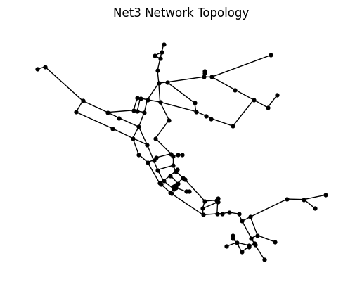
Figure 1. Topology of the Net3 water distribution network used for this study — nodes are junctions/tanks, lines are pipes.

2.2 The Biology, Simply
The model tracks two “populations” of the same bacteria as water flows through each pipe:
- Free-floating (suspended) bacteria — carried along in the bulk water.
- Biofilm-attached bacteria — stuck to the inside pipe wall, protected inside a biofilm layer.
Bacteria move between these two states — free cells can deposit onto the wall and join the biofilm, and biofilm cells can detach and re-enter the water. Both populations grow when nutrients (organic matter from the source water) are available, and both are killed off by chlorine, though wall-protected biofilm bacteria are typically harder to reach with disinfectant than free-floating cells. Six kinetic factors control the balance:
- Growth rate — how fast the bacteria multiply when nutrients are available
- Nutrient half-saturation — how nutrient-limited growth is
- Chlorine inactivation rate — how effectively chlorine kills the bacteria
- Wall deposition rate — how readily free bacteria stick to pipe walls
- Detachment rate — how readily biofilm bacteria break free back into the water
- Yield — how efficiently deposited bacteria convert into biofilm biomass

3. Results

3.1 Proving the Pipeline Works (Baseline Validation)
Before adding any biology, the chlorine-decay chemistry alone was validated: chlorine from the lake and river sources decays at different, source-dependent rates as it reacts with each source's own organic matter while traveling through the network. This is a well-established, literature-matched behaviour, and confirming it first ensures that any biological results that follow are built on a correct chemical/hydraulic foundation, not a modelling artifact.

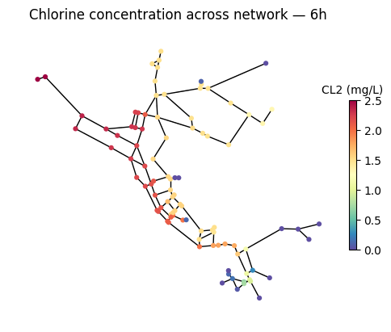
Figure 2. Simulated chlorine concentration across the network 6 hours in — warmer colours (near the Lake/River sources) show higher residual chlorine; cooler colours show it has decayed further downstream.
This map illustrates the core risk pattern intuitively: chlorine is strongest near the sources and weakens as water travels and ages through the network, exactly the kind of zone where pathogen growth becomes possible.

3.2 Where Does Pathogen Biomass Survive?
With the biology model switched on, suspended pathogen biomass (Xfree) was tracked across the whole network over a multi-day simulation, starting from a small uniform seed concentration everywhere.
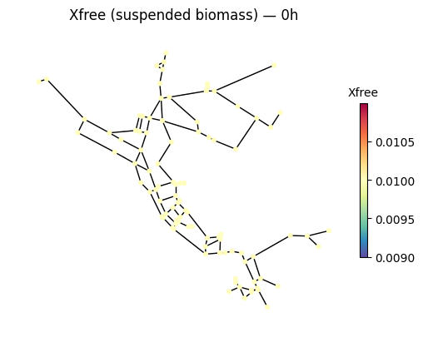
Figure 3. Suspended pathogen biomass at the start of the simulation — seeded uniformly (low, near-baseline levels) across the network.
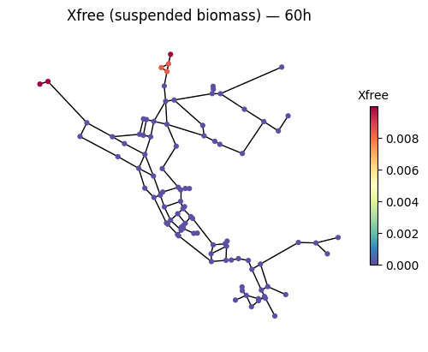
Figure 4. Suspended pathogen biomass after 60 hours — biomass has been driven to near zero almost everywhere except one low-flow corner near a source, where chlorine residual is weakest.
The pattern is exactly what the disinfection theory predicts: everywhere chlorine residual is adequately maintained, the pathogen population collapses over time. The only place biomass persists is a corner of the network where flow and chlorine residual are both lowest — consistent with real-world findings that stagnant, low-disinfectant zones (dead ends, poorly circulated storage, premise plumbing) are the highest-risk locations for Legionella colonisation.

3.3 Which Factor Actually Controls the Outcome?
To move beyond a single scenario, 112 full simulations were run, each with a different random combination of the six kinetic parameters (drawn using Sobol sampling, a structured sampling method used for global sensitivity analysis). A statistical method (Sobol sensitivity analysis) was then used to attribute how much of the variation in final pathogen biomass each parameter was responsible for.
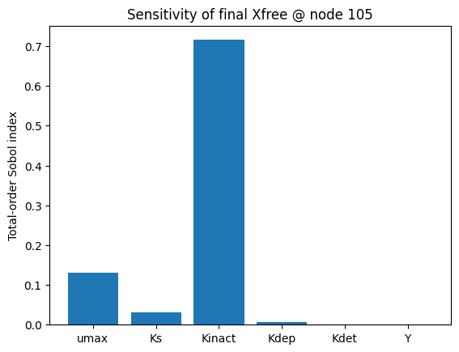
Figure 5. Total-order Sobol sensitivity indices for final suspended biomass — chlorine inactivation rate (Kinact) dominates, far ahead of growth rate (umax) and all other factors.
Key finding
Chlorine inactivation rate is the dominant control on how much pathogen biomass survives (Sobol total-order index ≈ 0.72) — more than five times as influential as growth rate (≈ 0.13) and over twenty times as influential as nutrient availability (≈ 0.03). Wall deposition, detachment, and biofilm yield had negligible influence on this outcome.

In practical terms: within the range of biological variability tested, disinfection efficacy — not how fast the bacteria grow or how much food they have — is the lever with by far the greatest power to control pathogen persistence in this network.

4. Interpretation — What This Means
- Maintaining chlorine residual throughout the network (not just at the source) is the highest-leverage intervention for limiting opportunistic pathogen risk — more so than trying to restrict nutrient loading or bacterial growth conditions.
- Risk concentrates spatially: even with an overall well-disinfected network, isolated stagnant or low-residual zones can become persistent reservoirs — this match documented real-world causes of Legionnaires’ disease outbreaks in premise plumbing.
- A mechanistic, physics-based model (rather than a purely statistical one) allows utilities to ask “what if” questions — e.g., what if residual is boosted in a specific zone — before implementing costly interventions.
- This modelling approach could support water-safety-plan style risk prioritisation, which connects directly to the standards and governance work relevant to ISO/TC 207 and youth engagement in environmental risk management.

5. Limitations & Next Steps
This is presented as an honest, in-progress working model, not a finished, field-validated tool:
- Kinetic parameter values are currently literature-informed placeholders, not yet fitted to Legionella/Pseudomonas-specific experimental data — next step is parameterising with literature-cited coefficients.
- The sensitivity analysis used a modest sample size (112 runs); the ranking of chlorine inactivation as dominant is credible, but confidence intervals are still wide. Increasing the Sobol sample size is planned to tighten this.
- The current results are for a single node/zone; extending the sensitivity analysis network-wide would confirm whether chlorine dominance holds everywhere or varies by location.
- Future work: literature-based re-parameterisation, larger-sample sensitivity analysis, and using the validated model as a foundation for a machine-learning surrogate (the pipeline already includes scikit-learn, XgBoost, LightGBM, and SHAP for this purpose).

6. Summary
One-line takeaway
A validated, physics-based simulation of a real water network shows that disinfection efficacy — not bacterial growth or nutrients — is the dominant, quantifiable control on opportunistic pathogen persistence, directly informing where risk-reduction effort should be prioritised in water safety management.

Tools used: WNTR, EPANET-MSX, SALib (Sobol sampling/analysis), Python scientific stack.

